three questions

Subject: three ques�ons
From: Aezja Munson <aezjam@a�.net>
Date: 12/16/2025, 10:42 AM
To: Rik Munson <blowintough@a�.net>

Inline image

Screen Shot 2025-12-16 at 10.40.16 AM.png

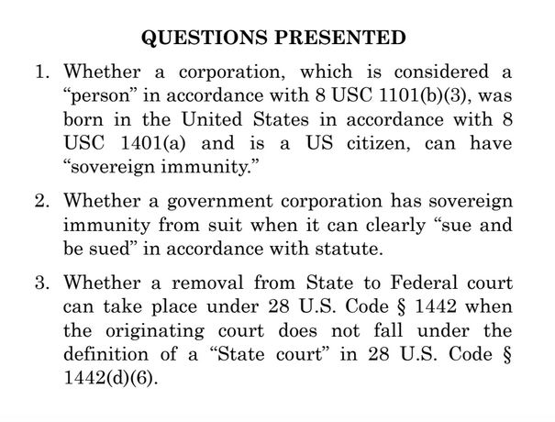

A�achments:
Screen Shot 2025-12-16 at 10.40.16 AM.png 142 KB

1 of 1 1/11/2026, 11:51 AM

